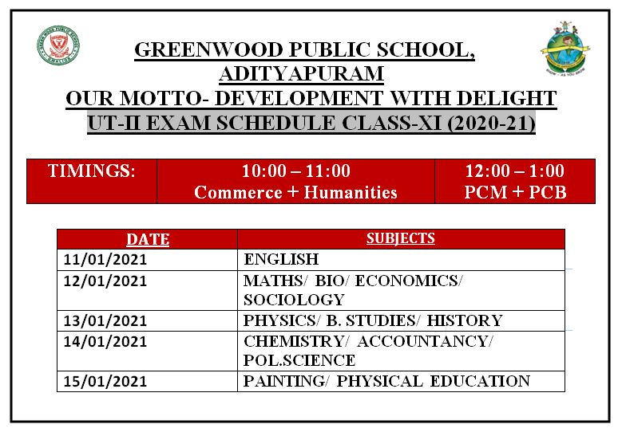

**10:00 A.M. – 11:00 A.M.**

**Commerce + Humanities**

**12:00 Noon – 1:00 P.M.**

**PCM + PCB**

**TIMINGS:**